**WEEK 6 HANDS-ON**

**REACT**

**Exercise 1**: HelloReact App

App.js

import './App.css';

function App() {

return (

<div className="App">

<h1>Hello React!</h1>

<p>This is my first React app.</p>

</div>

);

}

export default App;

App.css

.App {

text-align: center;

font-family: sans-serif;

padding: 20px;

}

index.js

import React from 'react';

import ReactDOM from 'react-dom/client';

import './index.css';

import App from './App';

const root = ReactDOM.createRoot(document.getElementById('root'));

root.render(

<React.StrictMode>

<App />

</React.StrictMode>

);

**Output:**

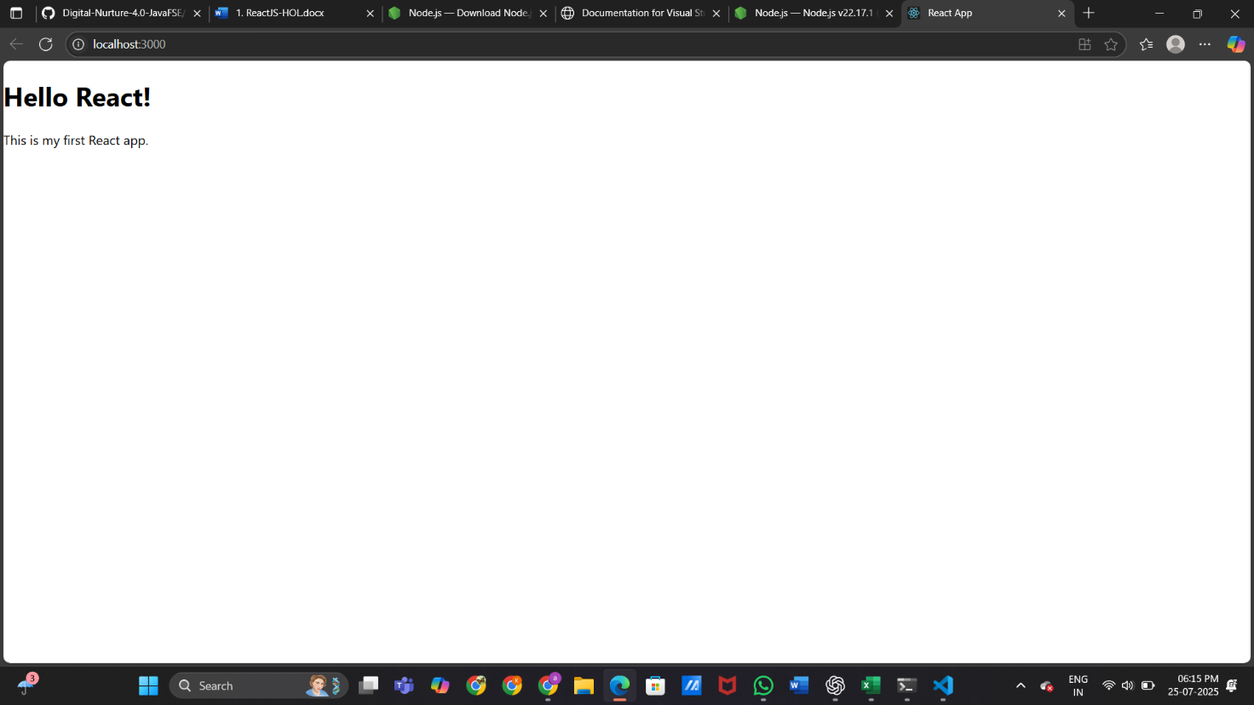

**Exercise 2:** Welcome Component

Objective: Create a new component and display it.

Welcome.js

import React from 'react';

function Welcome() {

return (

<div>

<h1>Welcome to React!</h1>

<p>This is a component.</p>

</div>

);

}

export default Welcome;

App.js

import Welcome from './Welcome';

function App() {

return (

<div className="App">

<Welcome />

</div>

);

}

App.js

import Welcome from './Welcome';

function App() {

return (

<div className="App">

<Welcome />

</div>

);

}

**Output:**

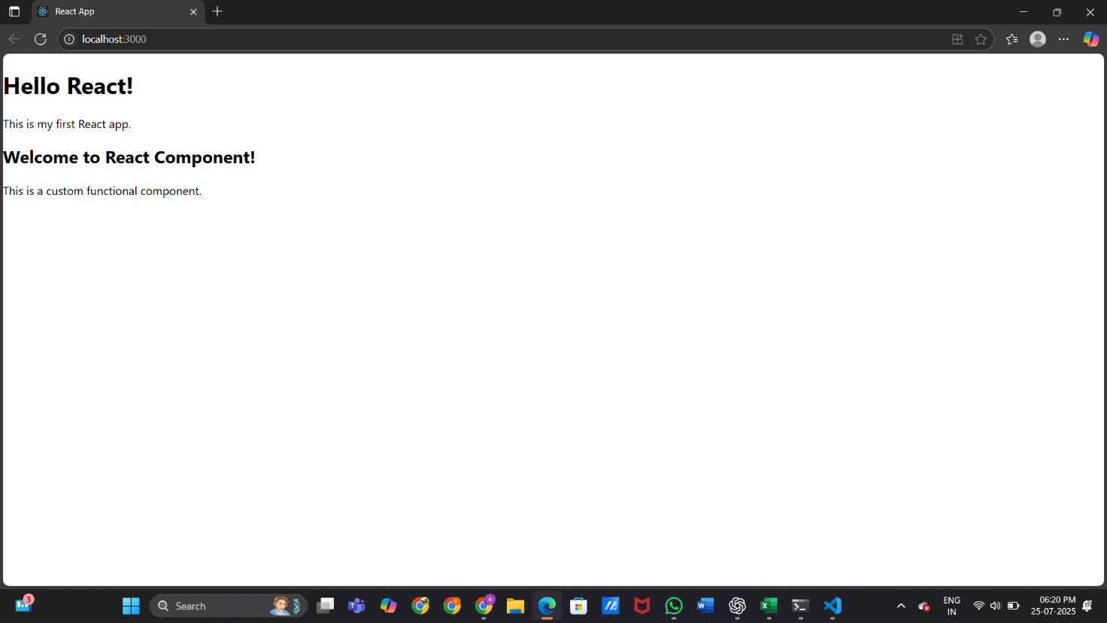

**Exercise 3:** React using Props

Welcome.js

import React from 'react';

function Welcome(props) {

return (

<div>

<h1>Welcome, {props.name}!</h1>

<p>This is a component with props.</p>

</div>

);

}

export default Welcome;

App.js

import './App.css';

import Welcome from './Welcome';

function App() {

return (

<div className="App">

<Welcome name="React Learner" />

</div>

);

}

export default App;

**Output:**

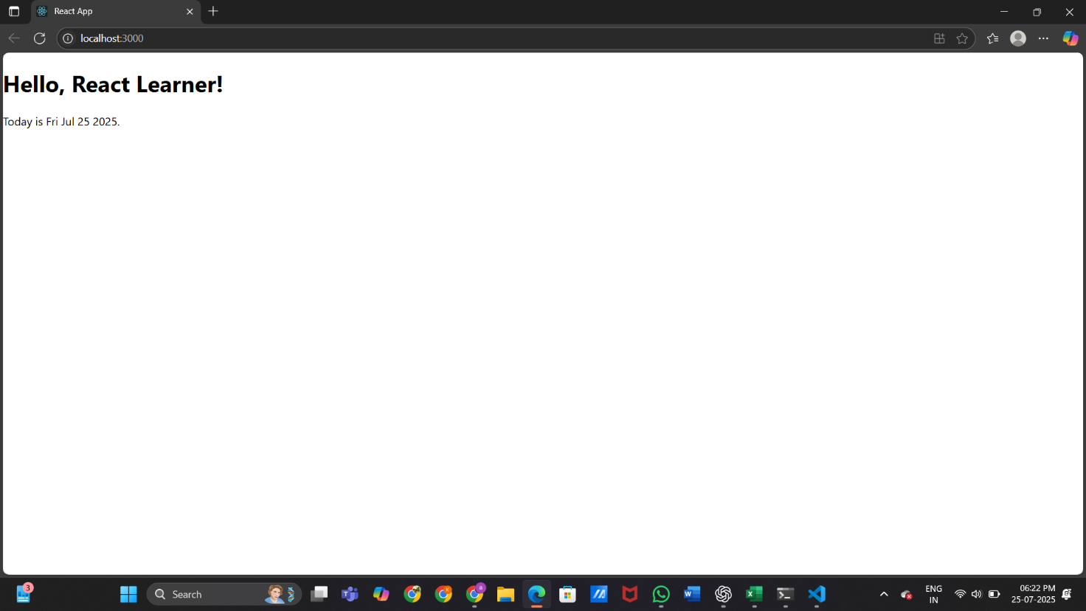

**Exercise 4:** Styling Components

Objective: Apply CSS styling and optionally add background image.

App.js

import './App.css';

import Welcome from './Welcome';

function App() {

  return (

    <div className="App">

      <h1>Hello React!</h1>

      <p>This is my first React app</p>

      <Welcome name="Aasriya" topic="ReactJS Props" />

    </div>

  );

}

export default App;

Welcome.js

function Welcome(props) {

  return (

    <div>

      <h2>Welcome to React</h2>

      <p>Hello, {props.name}! 👋</p>

      <p>You are learning: {props.topic}</p>

    </div>

  );

}

export default Welcome;

**Output:**

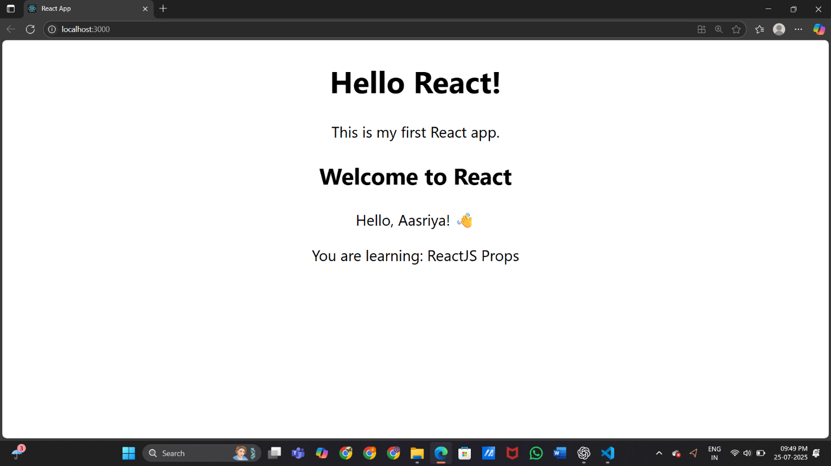

**Exercise 5:** Conditional rendering

App.js

import './App.css';

import Welcome from './Welcome';

function App() {

  return (

    <div className="App">

      <h1>Hello React!</h1>

      <p>This is my first React app</p>

      <Welcome name="Aasriya" topic="ReactJS Props" />

      <Welcome name="Satya" topic="Functional Components" />

      <Welcome name="Vedha" topic="JSX and Variables" />

    </div>

  );

}

export default App;

App.css

.App {

  text-align: center;

}

.App-logo {

  height: 40vmin;

  pointer-events: none;

}

@media (prefers-reduced-motion: no-preference) {

  .App-logo {

    animation: App-logo-spin infinite 20s linear;

  }

}

.App-header {

  background-color: #734F96;

  min-height: 100vh;

  display: flex;

  flex-direction: column;

  align-items: center;

  justify-content: center;

  font-size: calc(10px + 2vmin);

  color: white;

}

.App-link {

  color: #61dafb;

}

@keyframes App-logo-spin {

  from {

    transform: rotate(0deg);

  }

  to {

    transform: rotate(360deg);

  }

}

Welcome.js

function Welcome(props) {

  return (

    <div>

      <h2>Welcome to React</h2>

      <p>Hello, {props.name}! 👋</p>

      <p>You are learning: {props.topic}</p>

    </div>

  );

}

export default Welcome;

**Output:**

